Trumpet Ensemble Recording
Kenia Flavius
I recorded a trumpet ensemble consisting of 7 players total. I recorded using Audacity, which worked just fine. Before recording, I figured out how to allow Audacity to record using 4 mics, which took some trial and error, but it worked eventually. I used a spaced pair recording technique with 2 AKG Perception 420s in the omni pattern. There were also 2 PZM boundary mics that I placed on the floor. I recorded in room 247 in the music building, which is a smaller classroom. I forgot this room had carpeted floors and thought the boundary mics wouldn’t work, but the mics actually picked up a lot. I think it worked well because of the thinner carpet and there’s hard floor underneath it. The players were in a semi-circle and the mics were 4-5 feet away from them. If I did this setup again, I would have tried to move the mics farther back to see the difference. At the time I was hesitant to do this because of getting too close to the back wall and a fan in the ceiling that was making noise.
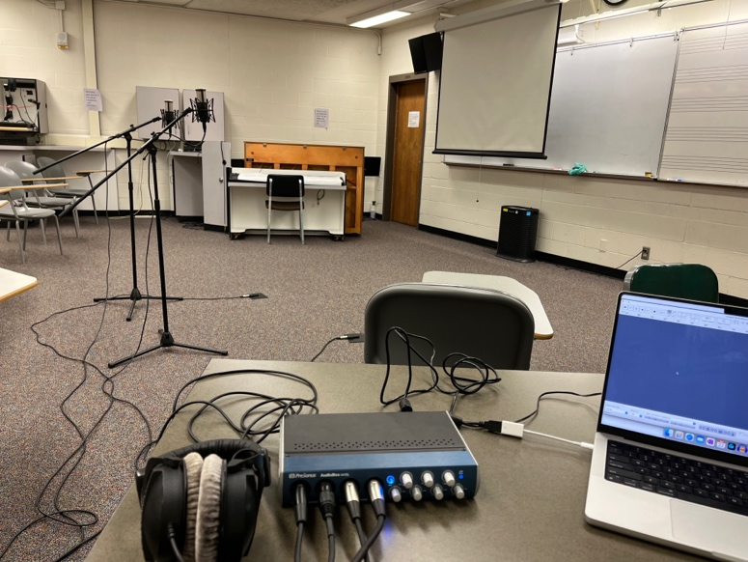
In terms of the mix, I did not EQ anything. I panned one omni to the left and the other to the right. I also did this to the boundary mics but only 50% to the left or right so there wasn’t a hole in the middle of the image. The mix is mostly omnis with some of the boundary mics mixed in to add warmth and fullness to the sound. I made sure to line up the tracks in Audacity as well to fix phase issues. I thought the stereo imaging and placement of the players in the recording was very true to how it was live.
