Ambisonic Recording
Kenia Flavius
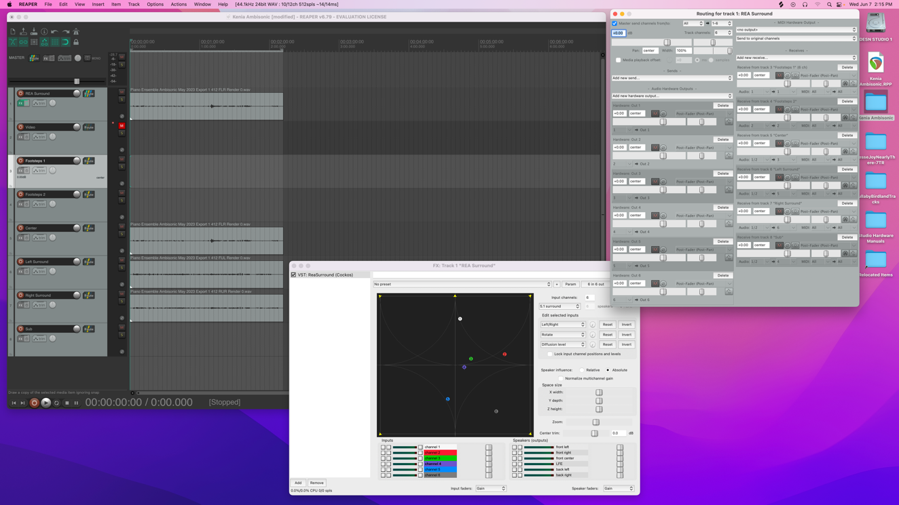
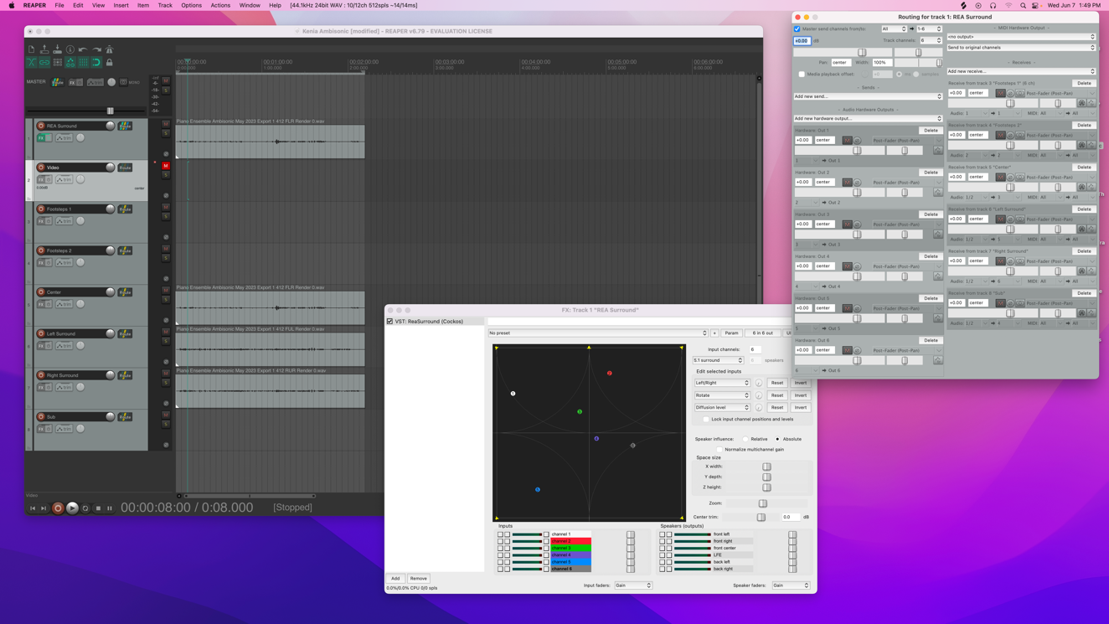
I used the recordings from the piano trio to create a left and right facing ambisonic mix. I used the reaper template in the CEB studio to adjust the positions of the tracks. I was able to do the left facing recording the way I wanted, with some of the sound still on the right side. For some reason, when I tried to do the same for the right side, it panned everything over to the right. When played through the speakers, the file played as it should with some sound on the left and most on the right. I couldn’t figure out what happened and while I tried several different fixes, nothing worked out. Luckily, reaper was straight forward and adjusting the recording in reaper to play through the speakers didn’t cause any problems.
Right Facing
Left Facing

