Mix Rescue: The Roger Hill Band
By Paul White
How can you enhance a live blues recording when all you have to work with is an MP3 of the mono ‘off-the-desk’ mix?
This month’s Mix Rescue is an unusual one, as the project didn’t involve separate tracks and in many respects it didn’t actually need ‘rescuing’, but I nonetheless thought it could benefit from some creative enhancement.

The story started when I was asked by John Benbow of SAM Records to look at some rather old ‘off-the-desk’ live recordings of some blues bands. These recordings were available only as data-compressed MP3 files, and despite the stereo nature of the files, judging by my goniometer readings and ears, they had been recorded in mono. My brief was to ‘do whatever possible’ to make these tracks sound good enough to be released as a live album.

On the plus side, the recordings were undistorted, reasonably balanced and well performed, and I could hear no obvious MP3 artifacts. However, with everything having been close-miked or DI’d, the sound lacked any real sense of depth, and the lack of stereo spread made them all sound a bit one-dimensional. In this short article, I want both to take you through the enhancement processes I opted to use here, and to explain the thinking behind them.

One of the songs in the set, and the main focus for this article, was the old blues standard ‘Dimples’. This version was performed by the Roger Hill Band, comprising Roger Hill on guitar, Roger Inniss on bass and Tony Bayles on drums. It was recorded in 2005 at the Roadhouse, Kings Norton, Birmingham in the UK, where all performances were routinely recorded directly off the desk and archived as MP3s. The other songs that were to make up the rest of the album were performed at the same venue by three or four different bands, and all the mixes responded to the same general treatment with just a few minor adjustments.

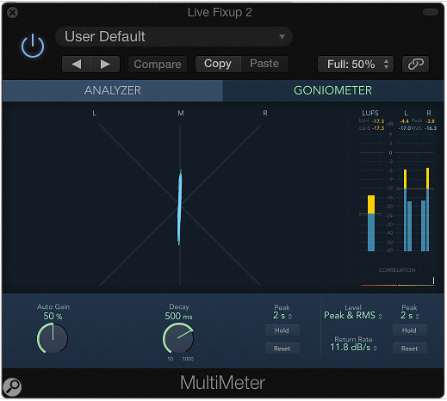
The goniometer confirmed what my ears were telling me — the original recording was a dual-mono affair.

Edits and Ambience
On my first proper listen, I noticed a couple of slightly dead guitar notes in the instrumental intro verse, but as these occurred during a repeated riff I was able to copy good notes from elsewhere and drop them into place without any problem. Other than trimming the start of the song and fading the end to allow the audience noise to drop away gently, nothing else needed to be done as regards editing, other than adding a second or so of silence before the intro to give old-school CD players time to pick up the track without losing the start.
A lot can be achieved using our old friends EQ, gentle compression and subtle limiting — in other words, a typical basic mastering chain — and they did eventually come into play here, although the lack of punch and rather two-dimensional sound needed addressing first.

Since the recording was made straight off the front-of-house desk’s master stereo mix, there was virtually nothing in there by way of ambience, so my instinct was to try some small-space (0.5 seconds or below) convolution reverb settings and, having found a suitable one, to add in just enough to glue the sounds together. After a little experimentation, it transpired that mixing in the reverb at around -20dB relative to the dry sound, and rolling off some of the low end to avoid muddiness, was enough to create the illusion of performing in a space, without the reverb unduly intruding on the proceedings. After trying a number of small-room and ambience impulse responses in Logic Pro’s Space Designer plug-in, the IR I finally settled on was called — and even I laughed at this — ‘Building Site’! Despite the name, with a little pre-delay (about 30ms) it offered just what I was looking for: it sounded bright, lively and not too coloured. Some of the other small spaces might also have worked, but after comparison this is the one I finally settled on. In addition to generating a little stereo width, the reverb also added back some of the sense of ambient detail that MP3 data compression tends to dilute.

Faking Stereo
Successful as the added ambience was in taking away the dryness of the original track, being mixed in at such a low level meant that it produced only a little stereo spread, so I resorted to some additional trickery: Logic Pro’s Stereo Spread plug-in. I could perhaps have got away without using this but wanted to inject as much of a sense of width as I felt possible into these mono recordings.

There are many similar width-expansion processors to Stereo Spread — in this type of plug-in, the audio is filtered into multiple bands, which are alternately boosted on the left and cut on the right and vice versa. It’s usually undesirable to do this at lower frequencies, as it can cause odd timbral changes in the bass, but if set to come in progressively from a few hundred Hertz upwards, it can sound very effective, provided you don’t overdo it. The are always some timbral effects when listening in stereo — they vary as the number of filter bands and frequency range is changed — and this was no exception, so I adjusted the settings by ear until I got what sounded like a gentle treble enhancement combined with some useful stereo spreading.

One benefit of this particular type of width-simulation process is that it causes no problems in mono: when the recording is played back in mono, the boosts and cuts on the left and right channels cancel out and so you’re left with your original mono mix. This kind of technique doesn’t really help place instruments in a specific place within a mix unless they occupy radically different frequency bands but it still creates a credible illusion of width. In combination with the reverb/ambience this started to show up on the goniometer as a useful degree of stereo spread and, more importantly, it certainly sounded more musically involving than the original!

Fattening Up
Next for the ‘fattening’, which turned out to be the most significant treatment I applied, and is a technique I’ve already revisited since completing this project. Having tried a few EQ tricks, I found that adding much in the way of lower mids, which is where I felt the mix needed more weight, simply added an undesirable boxiness. The process I finally settled upon was parallel processing where a slight EQ dip in the 200Hz boxiness range was combined with filtered parallel compression, to put some energy back into the mid-range but in a nicely controlled way.

Parallel compression, with or without EQ, is a fairly commonly employed technique these days, but my approach included a twist... I used a guitar cabinet simulator plug-in as the filter before the compressor, rather than relying on basic EQ. My reasoning was that guitar cabs include resonances that stretch out certain frequencies, and that factor is a big part of what makes an electric guitar sound punchy. It started out as an innocent ‘what if?’ experiment, but the cabinet emulation not only worked well in beefing up the guitar sounds but also added weight and warmth to the drums, bass and vocals, while somehow enhancing the overall live feel of the recording. Bypassing it during playback was like dropping a ‘veil of disappointment’ over the proceedings.
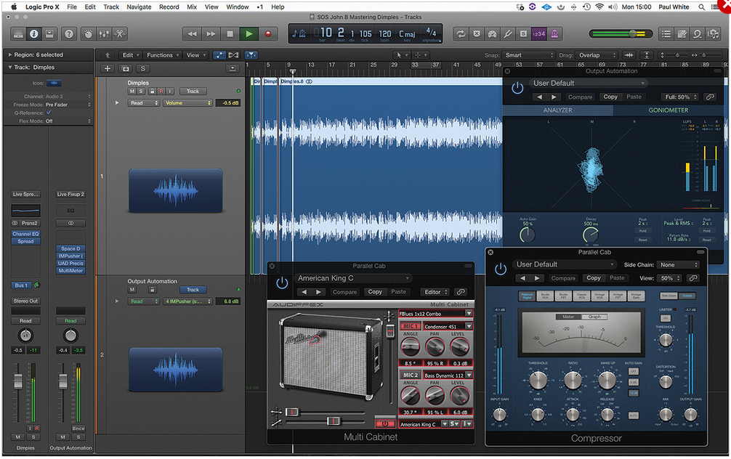
My alternative take on a parallel compression chain, featuring an amp/cab emulation in place of a more conventional EQ.

A further benefit was that this particular cabinet emulator (Multi Cabinet, free from Audified) allows for two modelled microphones in front of the cabinet, and the mic type, on/off axis positioning and distance from the cabinet can be adjusted for each. It offers a choice of cabinet emulations too — I found the 1x12 to sound best for this purpose. There are also separate pan controls for the two virtual mics, which can help further spread the pseudo stereo image. You can see the settings I used in the screen shot, though I’d encourage you to try different settings according to the material you’re processing.

By soloing the compressed cabinet and then adjusting the mic-distance parameters to produce something warm rather than simply phasey, I was able to fine-tune what was being added back into the mix before panning the two outputs hard left and right. Then, with both the mix track and the parallel processed feed running, I faded up progressively more of the compressed cabinet until it just started to fill out the sound. The trick, as so often, is not to go too far with it — to just add enough that you miss it when it isn’t there.
I didn’t apply as much compression as I normally would if doing straightforward parallel compression, and the settings I arrived at by ear were an 8:1 ratio with around 14dB of gain reduction combined with an attack time of 20ms and a release time of 50ms. I used Logic’s own compressor for this but pretty much any adjustable-ratio compressor should be up to the job.

Mastering Processes
Next, I tried the more usual mastering processes — some gentle, low-ratio compression, courtesy of Universal Audio’s 1176 UAD plug-in, followed by their UA Precision Limiter right at the end of the chain, just to catch any escaped transients. That was enough to make the track sound acceptably loud and ‘glued’, but I still yearned for a bit more punch, and having just reviewed the Waves Infected Mushroom Pusher plug-in, I knew that it had a very effective clipping section as well as a punch-enhancing compressor. So, bypassing the 1176 and bringing in this in its place, I looked to see what I could get out of it.

I didn’t really use IM Pusher’s multi-band tools other than the tiniest hint of HF enhancement and, instead, relied mainly on its punchy overall compression followed by a few decibels of output clipping. By using the clipper instead of the limiter at this stage, the transients stayed crisp while the central compression control (which has a separate Punch control that I turned around three quarters of the way up) beefed up the drum sound in a subtle but useful way.

After the quieter intro to the song, my parallel dynamic processing reduced the sense of impact when everything came in full belt, so I automated the Push control on the IMPusher to lift the level feeding into the clipping section by just a couple of dB at that point in the song. That seemed to do the trick.
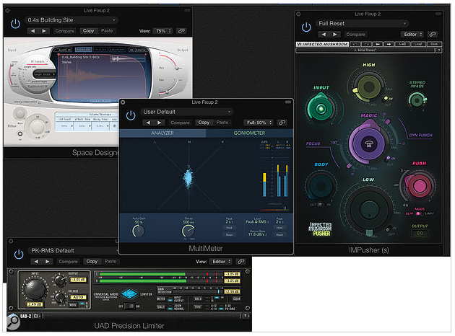
The ‘mastering’ chain, by which I mean the processors I applied to the whole signal in series. Note the additional stereo width being indicated by the goniometer!

As an alternative to the IM Pusher I also tried Softube’s Drawmer S73 emulation as a multi-band compressor and width enhancer, which produced worthwhile results using the Ambience setting — and I tried the Waves Greg Wells One Knob MixCentric mastering plug-in, also giving promising results with minimum effort — but in the end the IM Pusher just seemed to suit this particular job. There are lots of ways of arriving at a similar result with different tools — it’s much more about the processes involved rather than the specific tools you use.

The IM Pusher was inserted before the Precision Limiter, which was set only to trim a couple of decibels from the very loudest peaks — it was really there just as a safety net. I set the limiter output ceiling to -1.5dB so as to leave a little headroom for inter-sample peaks. The 1176 remained turned off, as I didn’t think any further compression was needed.

By now everything was sounding much bigger and livelier but the urge to keep trying things hadn’t yet gone away, so I brought in Slate Digital’s VTM open-reel tape-machine emulation, and even with its default settings it added a certain smoothness to the end result, while giving the low-level detail a subtle lift. However, I felt that it detracted ever-so-slightly from the clarity that I needed to maintain in order to balance the extra low-end weight, so I decided against using it here.

Getting Satisfaction
Clearly, with both parallel and overall processing going on, it’s important to ensure that each stage of processing contributes only as much as is needed to get you the result you want — it is all too easy to squash the life out of everything because you get carried away with processes in isolation. In this case, it was the ambience reverb and the compressed guitar cab that together made a more noticeable difference to the sound of the mix than just about anything else.

After much tweaking, taking a break, then going back to listen again, I was happy that I’d gone about as far as I could — but what would the client think?

I’ll leave you with some words from John Benbow: “When these recordings first came into my possession I was blown away by the musicianship on display. I had seen these guys perform many times and they were fully on form. However, the recordings themselves lacked punch. After all, it wasn’t a studio setting. What Paul has achieved with his ‘box of tricks’ is astonishing. There is now separation between all of the instruments, in each of which you can at last hear their full dynamic and timbral range. The room ambience and slight stereo spread puts me in the room with the band, which is exactly where I would want to be. Awesome!”

